blend.ai

Blend.ai is the ultimate inpainting tool designed specifically for enhancing car images, enabling users to edit and transform their visuals into captivating masterpieces with precision and ease. This tool is ideal for use in marketing materials and presentations.

**Background Remover**

Easily remove the background from your car images to make them stand out.

**How to Use:**

1. Navigate to the **Background Remover** tab.
2. Click **Choose File** to upload a PNG image from your computer.
3. Click **Submit**. The background-free image will be displayed on the screen.
4. To download the image, click the download icon located at the top right corner of the screen.

**Screenshot Guide:**

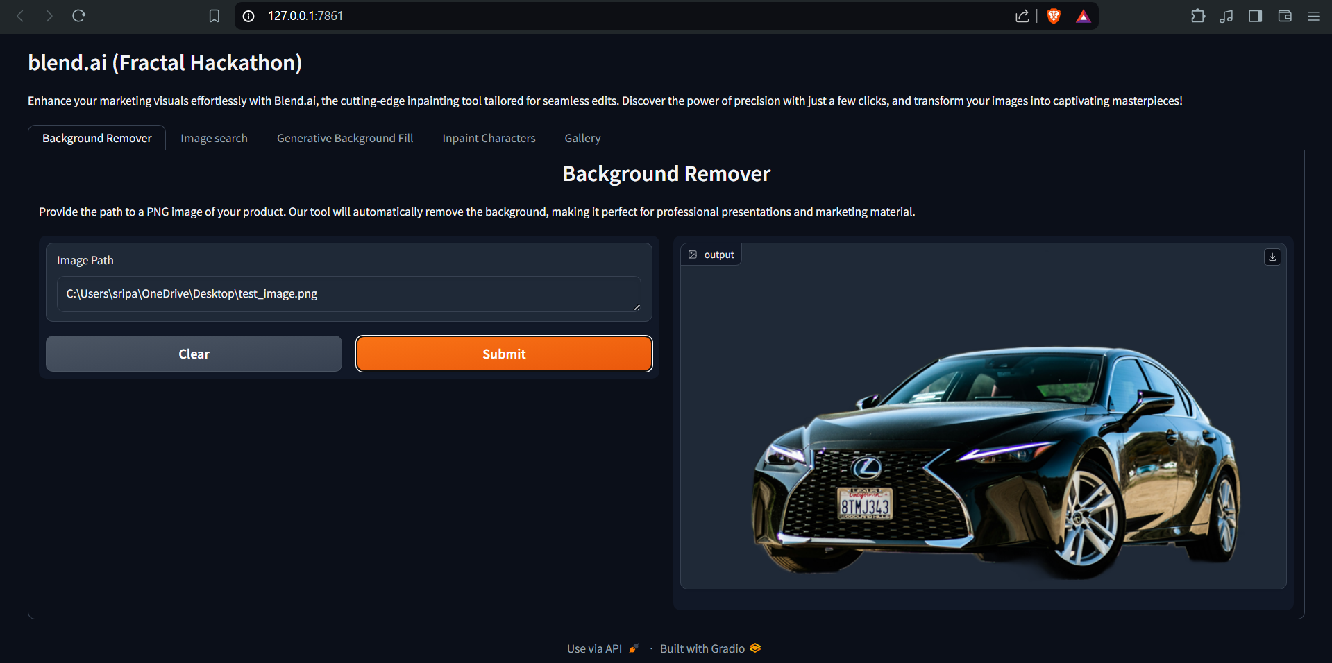

**Image Search**

Retrieve specific car images from our extensive repository using simple text prompts.

**How to Use:**

1. Go to the **Image Search** tab.
2. Enter your text prompt in the provided field.
3. Click **Search**. The top six similar images will be displayed based on your prompt.
4. To download an image, click on the desired image and then click the download icon at the top right corner.

**Screenshot Guide:**

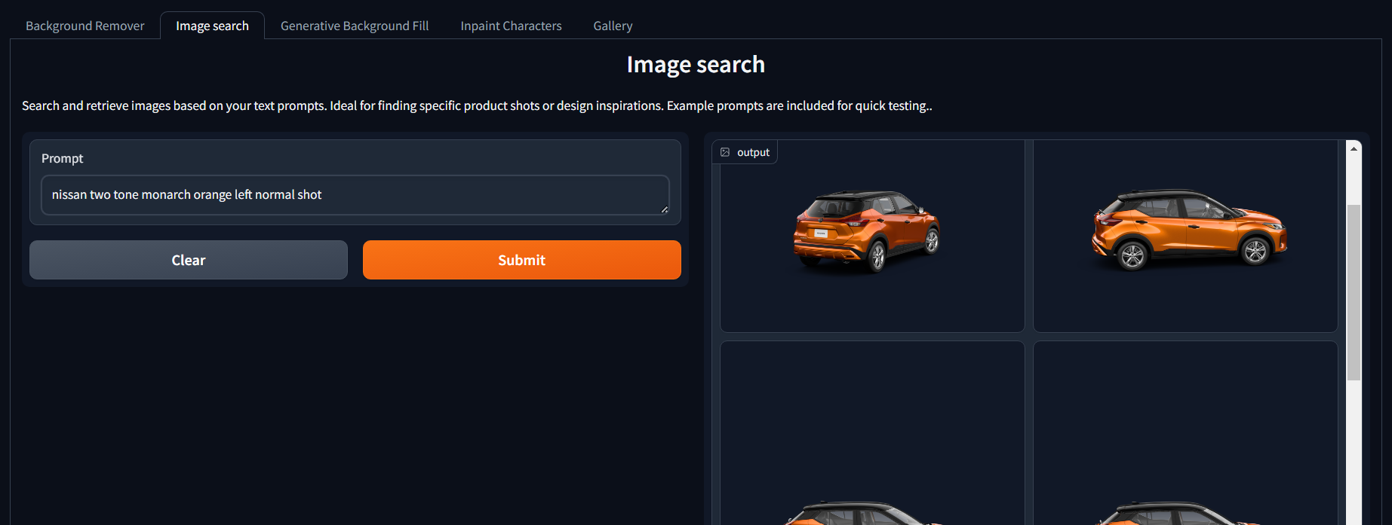

**Prompt Enhancer**

This tab helps enhance a simple prompt to improve prompt quality for image generation.

How to Use:

1. Go to the Prompt Enhancer tab.
2. Select the tab/section for which you need to generate.
3. Enter your text prompt in the provided field and click Submit.
4. The enhanced prompt will be displayed.

**Screenshot Guide:**

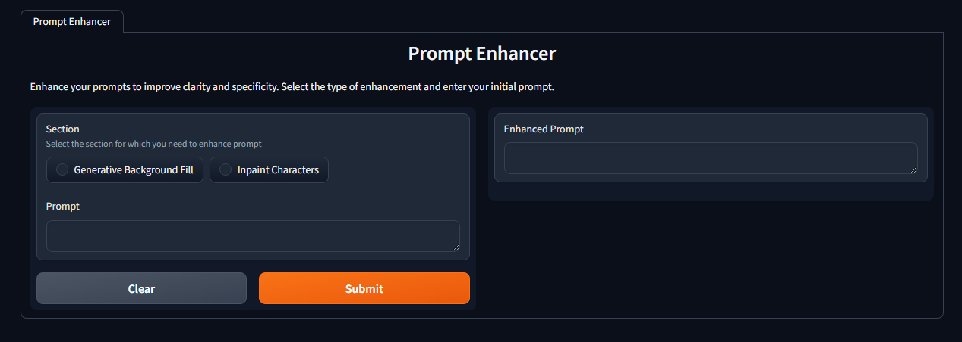

**Generative Background Fill**

Customize the background of your RGBA images based on creative prompts.

**How to Use:**

1. Upload an RGBA PNG image via **Choose File**.
2. Enter a positive prompt describing the desired background elements.
3. Provide a negative prompt to exclude unwanted elements.
4. Adjust the Kernel Size if necessary to refine the background margins.
5. Add a seed to ensure consistent output.
6. Select the desired output format (supports JPEG, PNG, WEBP).
7. Click **Submit** to see the transformed image with the new background.
8. To download the image, click the download icon at the top right corner.

**Screenshot Guide:**

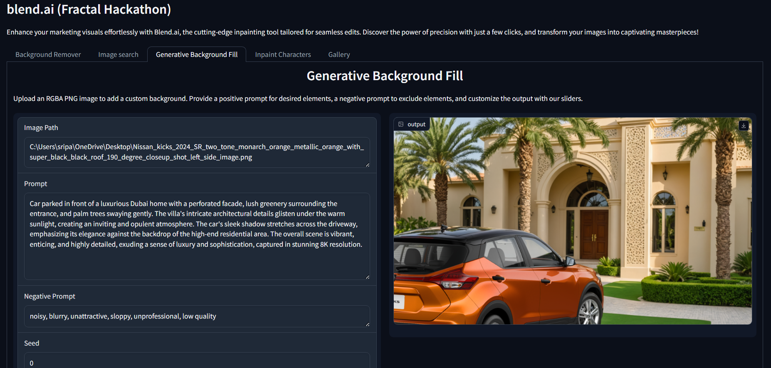

**Inpaint Characters**

Add characters or elements to your images to enhance their narrative and aesthetic appeal.

**How to Use:**

1. Upload an enhanced image from the **Generative Background Fill** section.
2. Use the masking tool to specify the area for new elements.
3. Upload an RGBA PNG image via **Choose File**.
4. Enter a positive prompt describing the character in the picture.
5. Provide a negative prompt to exclude unwanted elements.
6. Adjust the Kernel Size if necessary to refine the masked region margins.
7. Add a seed to ensure consistent output.
8. Select the desired output format (supports JPEG, PNG, WEBP).
9. Click **Submit** to integrate the new elements into your image.

**Screenshot Guide:**

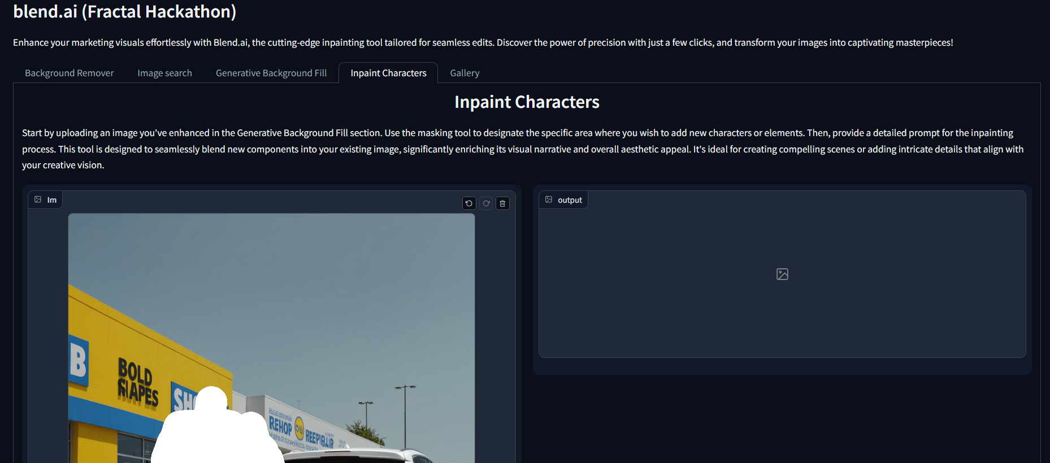

Icon to create mask is shown below.

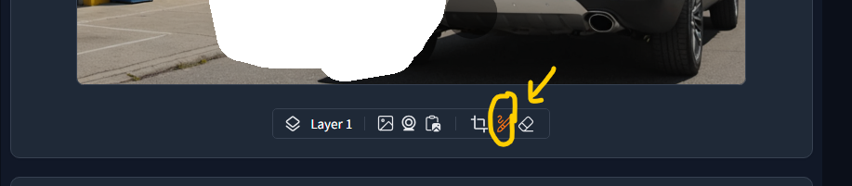

**Gallery**

Showcase images generated using the tool. Note: Currently, only the admin can add images to the gallery.

**How to Use:**

1. Navigate to the **Gallery** tab to view all generated images.
2. Click on any image to view in full detail.

